**Language Features of Extended Responses and Economic Writing**

There are a number of features and conventions that you need to adhere to when writing an extended response in the economics context.

1. **Language and Style**

Extended responses require a formal writing style, this means that students need to avoid:

* Colloquial words and expressions; “stuff”, “a lot of”, “okay”, “thing”
* Abbreviated forms; “can’t”, “doesn’t”, “shouldn’t”
* Two word verbs; “put off”, “bring up”

**Activity 1 – Re-write the sentences, replacing the informal expressions , abbreviated forms and two word verbs so formal sentences are formed.**

1. A primary education system was set up throughout Ireland as early as 1831.

­­­­­­_________________________________________________________________________________

1. The material amenities of life have gone up in Western society.

_________________________________________________________________________________

1. Unfortunately, since there are so many possible explanations, the correct one is difficult to find out.

_________________________________________________________________________________

1. The first National Government wasn’t intended to be a coalition government in the normal sense of the term.

_________________________________________________________________________________

1. The aggregate of outstanding balances went up and down a lot.

_________________________________________________________________________________

1. **Jargon**

Jargon refers to technical terminology used in a specialised field. Students need to have a comprehensive knowledge of the key terms and concepts for the course and effectively utilise this jargon within the context of their written response. This will enable concise and succinct responses that demonstrate a thorough grasp of the content.

1. **Abbreviations**

In economic writing abbreviations are commonly used. The writer first needs to spell out the full term followed by the abbreviation in brackets. For example:

* New South Wales (NSW)
* Australian Labor Party (ALP)
* Marginal Tax Rate (MRT)
* Australian Chamber of Commerce and Industry (ACCI)

Subsequent use of the term is then made by its abbreviation.

1. **The use of “I”**

Formal writing does not use personal language or subjective phrases. In grammatical terms this refers to the type of personal pronouns that can be used. A pronoun is a word that replaces a noun to save repetition of names or ideas. Writing in first person involves use of personal pronouns: I, me, my mine, we, us or our. Writing in second person involves use of personal pronouns: you, your, yours. Formal writing focuses on the content, not the writer, and needs to be written in third person. Third person pronouns are: they, their, it, its.

**Activity 2**

Complete the table, converting the sentences that are in first and second person to third person, by following the examples given. Provide three complete examples of your own.

|  |  |
| --- | --- |
| **First/Second Person** | **Third Person** |
| Our economy… | The economy |
| I believe Adam Smith’s theory of… | There is evidence to support Adam Smith’s theory of… |
| I conducted research on the federal budget… | Research was conducted on the federal budget… |
| Our government uses the taxation system to… |  |
| We pay tax as part of… |  |
| I agree with the government’s plan to… |  |
|  |  |
|  |  |
|  |  |

1. **The use of active voice in sentence construction.**

It is preferable to use active voice, where possible, to create a direct and concise message; this also makes your writing easier to read. The difference is illustrated below:

In an **active** sentence, there is a subject performing an action. For example “*Jason* threw the ball.” *Jason* is the subject.

In a **passive** sentence, the subject of the sentence is acted upon rather than performing the action, as in: “*The ball* was thrown by Jason.” *The ball* is the subject and it is being acted upon.

**Activity 3**

Complete the table, converting the passive sentences to active sentences by following the examples given. Provide two complete examples of your own. The subject of the sentence is in *italics*.

|  |  |
| --- | --- |
| **Passive Voice** | **Active Voice** |
| The *financial problem* was controlled by the accountant. | The *accountant* took control of the financial problem. |
| The government hands down the *federal budget* in May. | The *federal budget* is handed by the government in May. |
| It is the consumer who pays *indirect taxes.* | *Indirect taxes* are passed on to the final consumer. |
| The government can redistribute income through *tax policy.* |  |
|  |  |
|  |  |

**Structure of an extended response**

The structure of an extended response has three main components.

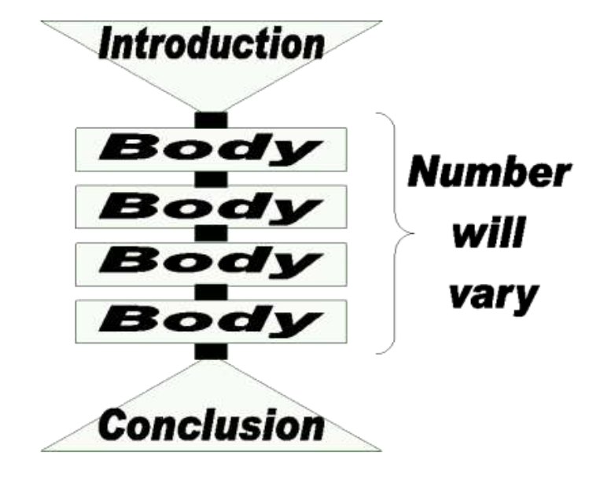

**Introduction**

The function of the introduction is to serve as a 'map' of the extended response, outlining to your reader the main argument and points which you develop in your essay. Most introductions begin with an orientation in the form of a brief general statement that leads the reader into the topic showing how the specific topic relates to bigger issues or to the discipline field. This is followed by your thesis statement, which is your concise response to the essay question, then an outline of the argument presented in the essay. You may find it useful to think of an essay's introduction as funnel shaped moving from the general to the specific.

**Body**

The function of the essay's body is to fully develop the argument outlined in the introduction. Each paragraph within the body of the essay elaborates on one major point in the development of the overall argument (although some points may consist of a number of sub-points, each of which will need a paragraph). The main point in each paragraph needs to be clearly stated in the form of a topic sentence, which is then supported with evidence.

**Conclusion**

The conclusion summarises the main points presented in the body of the essay and explicitly links these back to the introduction and the extended response question.

**Paragraph Structure**

Paragraphs are structured like micro extended responses, with three similar components:

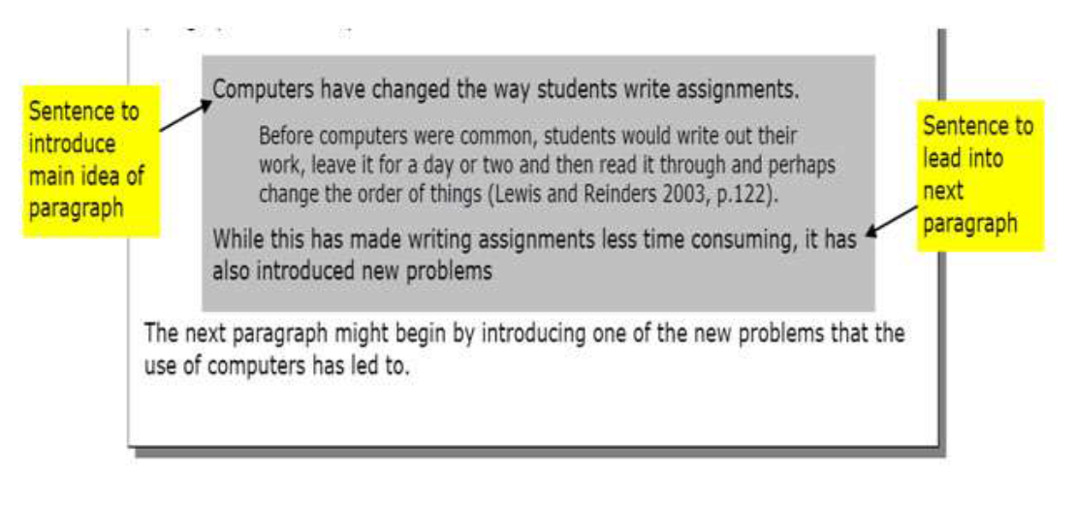1) Topic sentence: outlines the main idea that will be presented in the paragraph.

2) Supporting sentences: elaborate and provide evidence and examples to support the main idea.

3) Concluding sentence: summarizes the main idea of the paragraph, relates it to the main argument and leads the reader to the topic of the next paragraph.

**Activity 4 -** Annotate the example paragraph below with the three paragraph components outlined above.

**Scaffolds for structuring an extended response**

The information above provides a very generic outline of the main functions of the three structural components of a response. To effectively answer a question, the structure of the response changes depending on the directive key word utilised in the question.

**Glossary of key directive words**

**Account-** Account for: state reasons for, report on. Give an account of: narrate a series of events or transactions

**Analyse-** Identify components and the relationship between them; draw out and relate implications

**Apply-** Use, utilise, employ in a particular situation

**Assess-** Make a judgement of value, quality, outcomes, results or size

**Compare-** Show how things are similar or different

**Contrast-** Show how things are different or opposite

**Critically (analyse/evaluate)-** Add a degree or level of accuracy depth, knowledge and understanding, logic, questioning, reflection and quality to (analyse/evaluate)

**Define-** State meaning and identify essential qualities

**Demonstrate-** Show by example

**Describe-** Provide characteristics and features

**Discuss-** Identify issues and provide points for and/or against

**Distinguish-** Recognise or note/indicate as being distinct or different from; to note differences between

**Evaluate-** Make a judgement based on criteria; determine the value of

**Explain-** Relate cause and effect; make the relationships between things evident; provide why and/or how

**Identify-** Recognise and name

**Interpret-** Draw meaning from

**Justify-** Support an argument or conclusion

**Outline-** Sketch in general terms; indicate the main features of

**Propose-** Put forward (for example a point of view, idea, argument, suggestion) for consideration or action

**Recall-** Present remembered ideas, facts or experiences

**Summarise-** Express, concisely, the relevant details

**Synthesise-** Putting together various elements to make a whole

**Developing an extended response plan**

It is vital to take the time to develop a plan for your extended response. This ensures that you present your argument in a logically structured and substantiated manner.

**Step 1**. Analyse the question

To ensure that you understand exactly what is being asked and what is required in your answer you need to analyse the question. This requires identifying and classifying the key words. There are three types:

* Topic keywords specify the topic that is being addressed
* Aspect keywords specify the particular parts of the topic to be considered
* Directive keywords specify what you are being asked to ‘do’

**Step 2**. Identify the relevant information

Brainstorm all the points relevant to the topic and aspect keywords.

**Step 3.** Structure the information

The information in your answer needs to be structured according to the directive key word and the perspective you are taking.

* Refer to the scaffold for the appropriate key word. Analyse the structure in relation to the extended response question and the relevant points you have listed.
* Form the perspective that you are going to take.
* Organise the relevant points in a logical sequential order by identifying the main and supporting points in relation to the appropriate structure.
* Each main point forms a paragraph in the body of your response.

**Step 4.** Identify the evidence to support your argument

Match relevant and analytical details to your structured points. This will provide support to your argument. This can include graphs, tables, statistics and diagrams.

**Step 5.** Commence writing

You are now able to construct your introduction. Linked explicitly to the question and the key directive, it will orientate the reader to the topic, the main points that you will be using to develop your response and the position that you are taking. From here the body of your essay will follow the structure that you developed in your plan. Your response will then be completed with a concluding paragraph that summarises your main points in relation to your introduction and the question.

**Scaffolded plan for an extended response**

1) Analyse the question.

What are the topic key words? _______________________________________________

What are the aspect key words? ______________________________________________

What is the directive (doing) key word? _______________________________________

2) Identify, structure and substantiate the relevant information.

Fill in the table below:

* List all the points relevant for the topic and aspect in the first column.
* Refer to the scaffold for the directive key word, form your perspective and list the relevant points in a logical sequential order e.g identifying the main and supporting points, in relation to the appropriate structure in the second column.
* List the evidence- graphs, tables, statistics, diagrams etc- that will be used to support your arguments in the third column.

|  |  |  |
| --- | --- | --- |
| All relevant points | Points in sequential order | Evidence |
|  |  |  |

3) Write an introduction for the response that orientates the reader to the subject, introduces the points in the body of the essay and states the perspective you are taking.

This needs to be explicitly linked to the question.

4) Write a conclusion to the response that summarises the main points in the body of the essay, linked explicitly to the introduction and thus the question